**CIMI Agenda and Minutes**

**April 7, 2016**

**Co-Chairs:**

* **Linda Bird BIT PhD,** IHTSDO, [lbi@ihtsdo.org](mailto:lbi@ihtsdo.org)
* **Galen Mulrooney MBA,** U.S. Department of Veterans Affairs, Phone: USA +1 703-815-0900, [galen.mulrooney@jpsys.com](mailto:galen.mulrooney@jpsys.com)
* **Harold Solbrig,** Mayo Clinic, [solbrig.harold@mayo.edu](mailto:solbrig.harold@mayo.edu)
* **Stanley Huff MD,** Intermountain Healthcare, Phone: USA +1 801-507-9111  
  [stan.huff@imail.org](mailto:stan.huff@imail.org)

**REQUESTED ACTION:** *If you would like to participate on a task force of about 5 people to make a first draft plan for how we could merge FHIM and CIMI model content and processes please send a note to the CIMI co-chairs expressing your interest*.  Thanks, Stan

  The “CIMI Practitioners Guide to HIE Interoperability” is being developed by the CIMI workgroup. This document is typically versioned each Monday to incorporate the previous Thursday’s CIMI WG telecom technical discussions.  The current MS Word version is always available at: <http://1drv.ms/1TuV8PD>

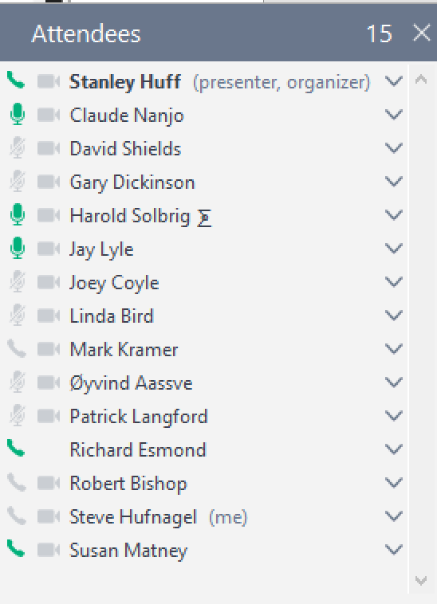

**Telecom:** Thursday US time, Friday Australia will be at 20:00 UTC.

<https://global.gotomeeting.com/join/754419973>  
  
**You can also dial in using your phone.**

United States : +1 (224) 501-3316  
Access Code: 754-419-973

**More phone numbers**

Australia : +61 2 8355 1034  
Belgium : +32 (0) 28 93 7002  
Canada : +1 (647) 497-9372  
Denmark : +45 89 88 03 61  
Netherlands : +31 (0) 208 084 055  
New Zealand : +64 4 974 7243  
Spain : +34 932 20 0506  
Sweden : +46 (0) 853 527 818  
United Kingdom : +44 (0) 330 221 0098

Annotated Agenda:

* Agenda review *(no change)*
* Upcoming meeting schedule
  + April 14 (next CIMI meeting)
    - Topic: SNOMED Template Binding
    - Stan will not be available on April 14
    - *Linda will probably not be available either*
    - SNOMED CT model meaning bindings to FHIR resources – Linda and Harold
    - Question from HL7 TQA team: Could we have Harold’s tool export MIF along with RF2?
      * *MIF allows integration of CIMI artifacts into HL7*
* CIMI paper submission to the SNOMED CT Expo in October – Linda, All
  + Claude and Stan to send edits by COB tomorrow (Friday)
  + <http://www.ihtsdo.org/participate/attend-ihtsdo-events/snomed-ct-expo>
  + submission deadline is April 29, 2016
* Plan for making the meeting agenda for Montreal – All
  + *People should send initial agenda items to Jay Lyle*
* **Continued explanation and discussion of the FHIM** – Stan, All

**Goal**: Tool-based continuity of models across CIMI and FHIM … avoiding translation.

Core Ref. Model, Ref Architypes, clinical patterns, leaf node instance data models

Must reconcile data types, data dictionary, terminology bindings

CIMI adopt FHIM models above leaf level, Entry Model for Observation,

Lab Observation Model, Numeric Lab Observation Model 🡪 CIMI leaf models

GENERALIZATION: FHIM contains the abstract models with more than one child and CIMI models are the terminal models

* CIMI model aggregations like Chem-7 panel and renal panel
* CIMI not model aggregate collections (e.g., reports, screen definition)
  + State business/value-proposition for joint use of FHIM and CIMI models
    - CQI, CDS vs. PC use cases
    - International vs HL7 WG vs Federal use cases, where CIMI & FHIM come into the Software Development Lifecycle (SDLC).
      * Use of UML, AML and ADL
      * Plans to reconcile content (avoid translation)
    - HSPC component and API use case
  + Plan for reconciling content of FHIM and CIMI
    - A first step would be reconciliation of the core reference model and associated base data types
    - HL7 processes and processes
      * Working with other WGs
        + Pharmacy WG input as an example
      * Balloting
      * “Which model is the source of truth?” 🡪 continuum
  + Terminology would need to be merged and aligned approved for both FHIM and CIMI
    - The need for terminology alignment is implied by the statement that we would align the FHIM and CIMI models, since the definition of CIMI logical models includes terminology bindings for both attributes and value sets.
  + Use of AML in representing FHIM models within CIMI?
    - Harold Solbrig – There may be an evolutionary path to accomplish this
  + What the technical division of labor should be
    - Patterns vs leaf level models – We discussed a proposal where FHIM would have responsibility for all models that represent “classes” of things, i.e. used as patterns for the creation of more than one child model. “Classic CIMI” would be used for all terminal or “leaf” models, that is, the last level of models that specify the structure and content of data instances.
    - There was general consensus that the above described strategy would require work, but that it was a worthwhile endeavor that should be pursued.
      * Working together to converging can bring divergent groups together …
  + What is the design division of labor between CIMI and FHIM?
  + Non-federal and non US (international) participation in FHIM
    - It was reiterated that CIMI models represent US and international content and that principle will be continued in a relationship with FHIM
    - People involved in the development of FHIM felt that the FHIM model and process could be delegated to HL7 CIMI, though we would need to ask permission for that, and it was not a sure thing.
    - We will probably need an MOU or a written agreement with the federal owners of FHIM for FHIM to become part of CIMI
    - **ACTION**: It was proposed that a task group of 5 or fewer people be formed to make a plan for merging the FHIM and CIMI models that considered all of the points made above. The plan would be brought back to the whole CIMI group for review, edit, and approval.
      * Linda Bird suggested there be international representation
  + Tools to compare FHIM and CIMI where there is overlap
    - Richard’s tools to do a “DIF” among models
    - Model Driven Health Tool (MDHT),
    - Model Driven Message Interoperability (MDMI)
    - Yosemite
  + There is a need for versioning of both CIMI and FHIM models
  + What would the plan be for transitioning from the current state to a new state?
  + What should be balloted? How would this new joint product fit into the HL7 process?
    - Review of patient, provider, orders, medication, etc.
  + HSPC use of the models?
    - HSPC has a documented decision to use CIMI models as its basis for interoperability
  + Adoption of FHIM by HL7 (since FHIM has been outside of usual HL7 process)
    - Reconciliation with other HL7 WGs and models
    - Is FHIM process amenable to HL7 open approach (balloting)?
    - CIMI International, US Realm is constrained subtype, Federal Realms?
* **Richard asked for examples of models outside of lab:** Outside of Lab Observations you have problem models for systemic illnesses diagnoses patterns (diabetes) with pre and post coordination versus Fractures or rash patterns which have local extent and alleviating conditions or negation (where something does not apply).
* **\*\*\* WE STOPPED HERE on Apr 7, 2016 \*\*\***
* Review of FHIR proposed Vital Signs panel – Stan
  + see <http://argonautwiki.hl7.org/index.php?title=Vital_Signs>
* Would CIMI be willing to host other artifacts? – Claude
* Future topics
  + IHTSDO work for binding SNOMED CT to FHIR resources – Linda, Harold
  + Transform of ICD-10 CM to CIMI models - Richard
  + Which openEHR archetypes should we consider converting to CIMI models?
  + Model approval process
  + Model transformations
  + What models do we want to ballot?
  + Semantic terminology bindings at the level of the whole model
    - Is it correct to bind “id” nodes to terminologies without going through an “at” node?
    - Test code should be bound to LOINC; should the root also?
  + Should we have a template level of models for CIMI as patterned on openEHR processes?
* Any other business